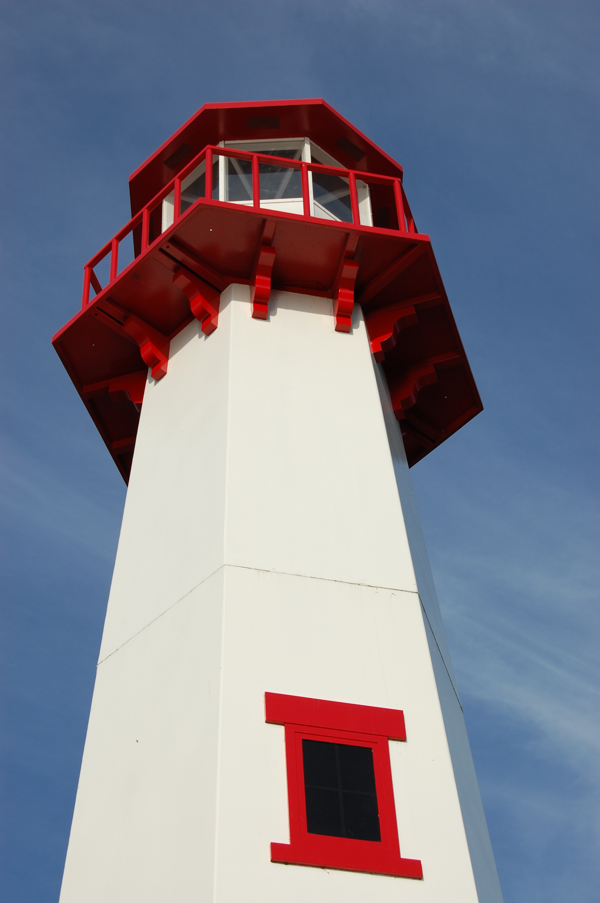
THE LIGHTHOUSE

Newsletter for July 2017

Light is shed upon the righteous and joy on the upright in heart. Psalm 97:11

Message from Our Pastor

Dear Sisters and Brothers in Christ,

As I sit here and type this newsletter I have just finished an 11 hour drive back from Iowa. I spent some time there with Army buddies whom I deployed and served with over my 23 year career in the Iowa Army National Guard. Most important of all, I spent some very precious and sacred time with family.

It was a wonderful time of renewal for me. Time I am truly grateful for. On that long car ride, I had time to think and give thanks for how blessed I am to serve two awesome congregations in the UP, land of big water and big woods or better yet a saying that says it so well, “906 - God’s Area Code”!

Then rolling through Wisconsin where I was born because it was the closest hospital to where we lived in Iowa (can you sense a hint of rivalry here?) and spent one of the most life changing years while I was on Internship for seminary.

Then slightly down a hill to the Iowa-Wisconsin border there is a bridge that is much smaller, but just as special to me as the Mighty Mac, which crosses the Mighty Mississippi. It never fails to bring a tear to my eye when I cross it, because I’ve crossed it coming home from deployments and on numerous other occasions when I have been away from home for a while.

It’s always strange, because a line from the movie “Field of Dreams” never fails to come to mind, “Is this Heaven?... No, it’s Iowa!” That movie, by the way, was filmed only 15 miles from where I grew up and even closer to where Catherine grew up! Little did you know, she is a movie star. She was an extra in the scene where they were arguing about burning books in the High School gym and she was in one of the hundreds of cars in the very last scene going to the field, because “if you build it they will come”. Since the scene was shot at night, I have no idea which set of headlights belonged to the car she was in but I will always know one of them contains my future movie star wife!

I am sharing this with you all because I am thankful. I’m thankful for God calling me here to serve you. I’m thankful that you have allowed me to take the time to spend with my family and friends. I’m thankful for all the gifts God has given me, and all the memories they bring and continue to bring.

I pray that you take time this summer for giving thanks and renewal.

Yours in Christ,
Pastor David

Newsletter

The Newsletter was not adopted

Noisy Offering

The noisy offering for July 2nd will go to ELCA Always Being Made New Campaign.

Vacation Bible School

Vacation Bible School will be held at the United Methodist Church in August. We’ll be looking for volunteers if you’re interested contact Pastor Dave.

Adult Bible Study

Bible Study at Trinity will be Tuesdays at 6 pm. Zion Bible Study will continue in July at 7 pm with Women of the Bible

HOPE Chest

The new summer HOPE Chest hours are:

Fri - Mon: Closed
Tues - Thurs: 10 am – 4 pm

Volunteers are needed! Please consider giving of your time and talent to our mission. Our volunteers are vital to the success of the HOPE Chest. There is a wide range of volunteer positions available.

Birthdays in July

July 1 Max Coburn
July 7 Tracy Movalson
July 7 Joe Schlehuber
July 8 Cody Blair
July 8 Adam Chambers
July 9 Fred Feleppa
July 13 Jane Chambers
July 13 Christian Stenson
July 15 Jake Dodds
July 16 Donna Harju
July 17 Candy DeKeyser
July 17 Page Paul
July 17 Sara Sorenson
July 24 Aiden Stenson
July 24 Kaiden Stenson
July 27 Cindy Hendricks
July 28 Richard Galor
July 28 Wendy McCluskey
July 30 Mary Belonga

Baptismal Anniversaries

July 3 Brian Olsen
July 7 Emma Feleppa
July 16 Alicia LaLonde
July 16 Rebecca LaLonde
July 17 Lilyan Stenson
July 21 Brenda St. Onge
July 21 Loni LaJoice
July 27 Eunice Therrian
July 29 Kristine McDonald

Prayer List

(If you would like someone added to the prayer list, email or call the church)

Mary Belonga, Dave & Lois Movalson, LaTaunya Paquin, Barb Lehto, Bev Kammers, Joe Chalmers, Nadine Dandona, Patty Thibault, Karen Fowler, Delores Marshall, Bill & Sandy Tielbar, Walter & Jane Puccio, Linda Wilkins, Bill Anderson, Karen Kammers Sparks, Joel Morabito, Rick Brown, Eric Rose, Jackie Kallstrom, Ingrid Thompson, Russell Winberg, Tom & Taffy Coffey, Charlie Doud, Richard Galor, Sarah Marolf, Eunice Therrian, Wes Pechta, Lou Hitts, Jack Dyer, Fred Dandona, Rick Weiss, Toni Leny, Judy Ryerse, Mandy Jones, Carol Watson, Bea Zak, Judy Schlehuber Bridges, Aiden, Rodney Novenske, John Lata, Jody Gustafson, Owen, Bernie, and all of our homebound & in long term care

Trinity Worship Families

July 2 Kennedy Family
July 9 Movalson Family
July 16 Baron Family
July 23 Chalmers Family
July 30 Rose Family

Zion Funeral Committee July - September

Team Leader: Linda Wilkins (430-1465)
Co-leader: Lorraine Graham (643-8419)

Servants for Zion

Ushers & Greeters

July 2 Casey & Angie Brake
July 9 Donna Harju & Lorraine Graham
July 16 Mark & Carol Elmblad
July 23 Jerry & Susan Fenlon
July 30 Delores & Cliff Marshall

Lectors

July 2 Betsy Turf
July 9 Dawn Akers
July 16 Sandy Feleppa
July 23 Cathie Tielbar
July 30 Fred Feleppa

Communion Assistants

July 2 Lorraine Graham
July 9 Karen Schlehuber
July 16 Mary Christiansen
July 23 Steve Christiansen

Altar: Lorraine Graham
Money Counters: Lana Lennington and Dena Barker

The Usher duties are:
- Arrive 30 minutes before church
- Put up song numbers from the bulletin
- Pass out bulletins and welcome guests
- Help with the offering and communion
- Record attendance

We will be providing the Long Term Care Service on June 9th and June 18th. Please help out if you can.

Council Meetings

No Zion Council meeting in July
Trinity Council – 6 pm, July 19th

Zion’s Council Members
President: Steve Christiansen 298-1051
Vice-President Karen Schlehuber 643-0311
Co-Treasurers: Dawn Akers 643-7552
Co-Treasurers: Lana Lennington 643-6576
Secretary: Lorraine Graham 643-8419
Mary Christiansen 235-6123
Robert Marshall 643-8936
Dena Barker 430-1460
Paul Shepard 984-2069

Trinity’s Council Members
President: Jerri Rose 292-5570
Vice-President Sharon Chalmers 292-5440
Secretary: Tracy Movalson 292-5581
Treasurer: Pega Kennedy 292-5633
Co-Treasurer: Jim Rose 292-5570
Financial Secretary: Tom Gustafson 292-5460
WELCA: Pega Kennedy 292-5633
John Kennedy 292-5633
Lois Movalson 292-5581

Treasurer's Report for Zion
January 1, 2017 through June 19, 2017
Income:
 | Amazon Smile Foundation | $6.38
 | Building | $75.00
 | Church Use Income | $915.00
 | General | $26,554.21
 | Fund Raising - Soup Luncheon | $1,518.90
 | Thrivent Financial Income | $446.00
 | Trinity Share | $5,656.18
 | TOTAL |  | $35,171.67
Expenses:
 | Administration | $1,329.81
 | Benevolence | $996.64
 | Church Maintenance | $6,580.44
 | Education | $342.40
 | Parsonage Maintenance | $1,705.69
 | Pastoral | $22,890.14
 | Worship | $1,688.19
 | --To Building Fund | $0.00
 |  |  | $35,533.31
 |  |  | -$361.64
****************************************************
Thrivent Financial Investment Fund |  |  | $288.07
General fund balance: |  |  | $249.55
Kitchen/Building Fund balance |  |  | $1,406.11
General fund owes building fund: |  |  | $75.00
General fund owes Mission Endowment fund: |  |  | $7,995.00

Zion Lutheran Council Meeting
June 21, 2017

Zion Council meeting was cancelled.

Trinity Council Meeting Minutes
June 20, 2017

Opened at 6:20 pm

Present: Pastor Dave, Jerri & Jim Rose, Pega & John Kennedy, Tracy Movalson, Lois Movalson, Tom Gustafson, and Sharon Chalmers

Pastor led the meeting with a reading from Portals of Prayer 1 Timothy 6:12 “A Good Fight”.

Pastors Report: A good month. Performed a wedding. Our next study will be Adult Catechism.

Secretary’s Report was read and approved.

Treasurer’s Report was read and approved.

Financial Secretary’s Report was read and approved.

Old Business:

Midsummer Pole: Memorial to Sharkey Movalson. His son, Bill, was the “lyncher”.

Benevolence…We will send scholarship money to Wartburg Seminary and NGLS Seminary.

We will purchase new deck for parsonage.

New Business:

We need new cupboard to store paraments. See Ray Baron

Bishop Finnegan’s installation is October 21, 2017 in Marquette.

Meeting adjourned at 7:00 PM
Respectfully Submitted by Tracy Movalson, Secretary

Contact Information

Pastor David Tielbar may be reached at 906-984-2051 or at david.tielbar6@gmail.com. In an emergency, you can reach the Pastor’s cell phone at (563) 880-4512

Church telephone: 906-643-7870 - Answering machine
The secretary will usually be in the office on Tuesday and Thursday mornings from 9 – 12

To email the church is: ziontrinity950@yahoo.com
The website is at http://zionstignace.com/home.html
- Find us on facebook at www.facebook.com/zionstignace

Zion Evangelical Lutheran Church and Trinity Lutheran Church are congregations of the Northern Great Lakes Synod and the Evangelical Lutheran Church in America.

Trinity’s Sunday Service is at 9 a.m.
Zion’s Sunday Service is at 11 a.m.





Have a safe and happy 4th of July!

